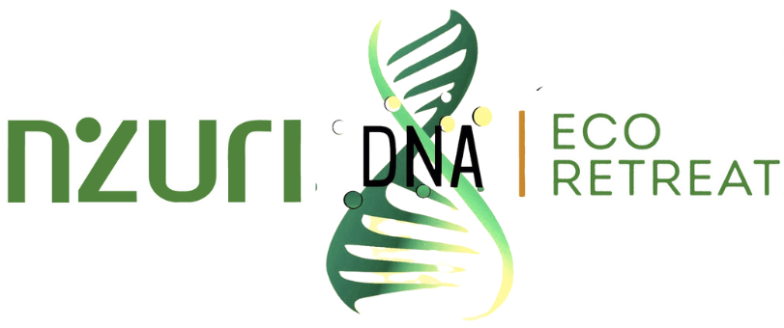

Guiding Document

- Social Enterprise Information
A.1. Assessing the Need
HEALTH AND WELLNESS
In our increasingly fast paced lives, the incidence of anxiety, stress and depression has risen significantly over the past few years. In Barbados in particular, our sedentary lifestyles and poor dietary habits have contributed to the prevalence of non-communicable diseases and high levels of required medical interventions. The COVID-19 pandemic and resulting economic crises across the globe have negatively impacted many people’s health and wellness and created new barriers for people suffering from mental illness. Research conducted during the pandemic points to rising concerns around mental health and wellbeing for children and their parents.

ENVIRONMENT
Our retreat space in the Scotland District, in the northeast of Barbados, is hilly and exposed to the Northeast Tradewinds, and subject to heavy rainfall and accelerated erosion. These factors, combined with forest clearing, unsound agricultural practices and housing development, create a significant problem for this part of the country in the fight against land degradation and land slippage. This results directly in damage to properties and loss of agricultural productivity through the damage to the top soil.

Because of Barbados’ extensive drainage network, sediment is transported to the near shore marine environment and this is exacerbated by the factors noted above. Harmful pesticides, herbicides and fertilisers also reach the coastline, affecting water quality and marine ecosystems. This directly impacts those who live and make a living in these areas. It is important to introduce eco conscious methodologies to farming and doing business that are more in alignment with our natural habitat and mitigate the threats to our ecosystem. It is also important to share the knowledge and best practices adopted with our beneficiaries and those with whom we collaborate in developing this enterprise.

EDUCATION
Barbados has deep roots in bush medicine practices. There is a vast amount of untapped and rich potential and information related to medicinal plants and their healing properties. In addition to modelling the appropriate eco-friendly approaches, it is important to provide more direct guidance on how to operate in concert with our environment. Nzuri’s workshops, webinars and podcasts will speak to health and wellness practices and greater self care, protection of the environment and how to employ more nature based and herbal remedies for our own healing.
A.2. Social Enterprise Description
Nzuri-DNA Eco Retreat provides high quality experiences to a wide cross section of society seeking a rejuvenating getaway. We are offering several retreat packages that include camping, hiking and bike trails, massage therapy, movement (yoga, dance, Pilates), meditation, energy healing, sound therapy and healthy meals. Services also include various wellness events and activities, workshops and walking tours. We intend to host markets, partnering with other farmers and entrepreneurs to sell organic produce, foods and natural remedies and other natural products.

ADDRESSING HEALTH & WELLNESS
Our remote multi-acre property provides an idyllic, natural oasis for “a true escape” where our guests can come to decompress, detox and unwind. It is the ideal getaway for those who may be stressed, burnt out, suffering from screen fatigue and the anxiety associated with the COVID-19 pandemic or any other life burden. The safe, wholesome environment promotes self care and introspection and our hosts will provide the guidance and direction to encourage guests to incorporate and/or continue healthy self care practices in their daily lives.
Our guests enjoy an unforgettable wellness experience with customisable holistic wellness packages provided by trained and knowledgeable professionals. We provide delicious, nutritious meals that are prepared for our guests from the best organic produce grown on our farm or supplied by a trusted partner farm. Guests may sit around the outdoor fireplace, listening to music and watching the food as it is prepared. The combination of activities offered engage the mind, body and spirit in a positive, nourishing way.

We have already entertained many guests in our rustic space. They have been treated to exceptional massages and detoxing foot soaks, camped out overnight, gone hiking along our natural spring, joined us for moonlight experiences and enjoyed the beautiful outdoors.

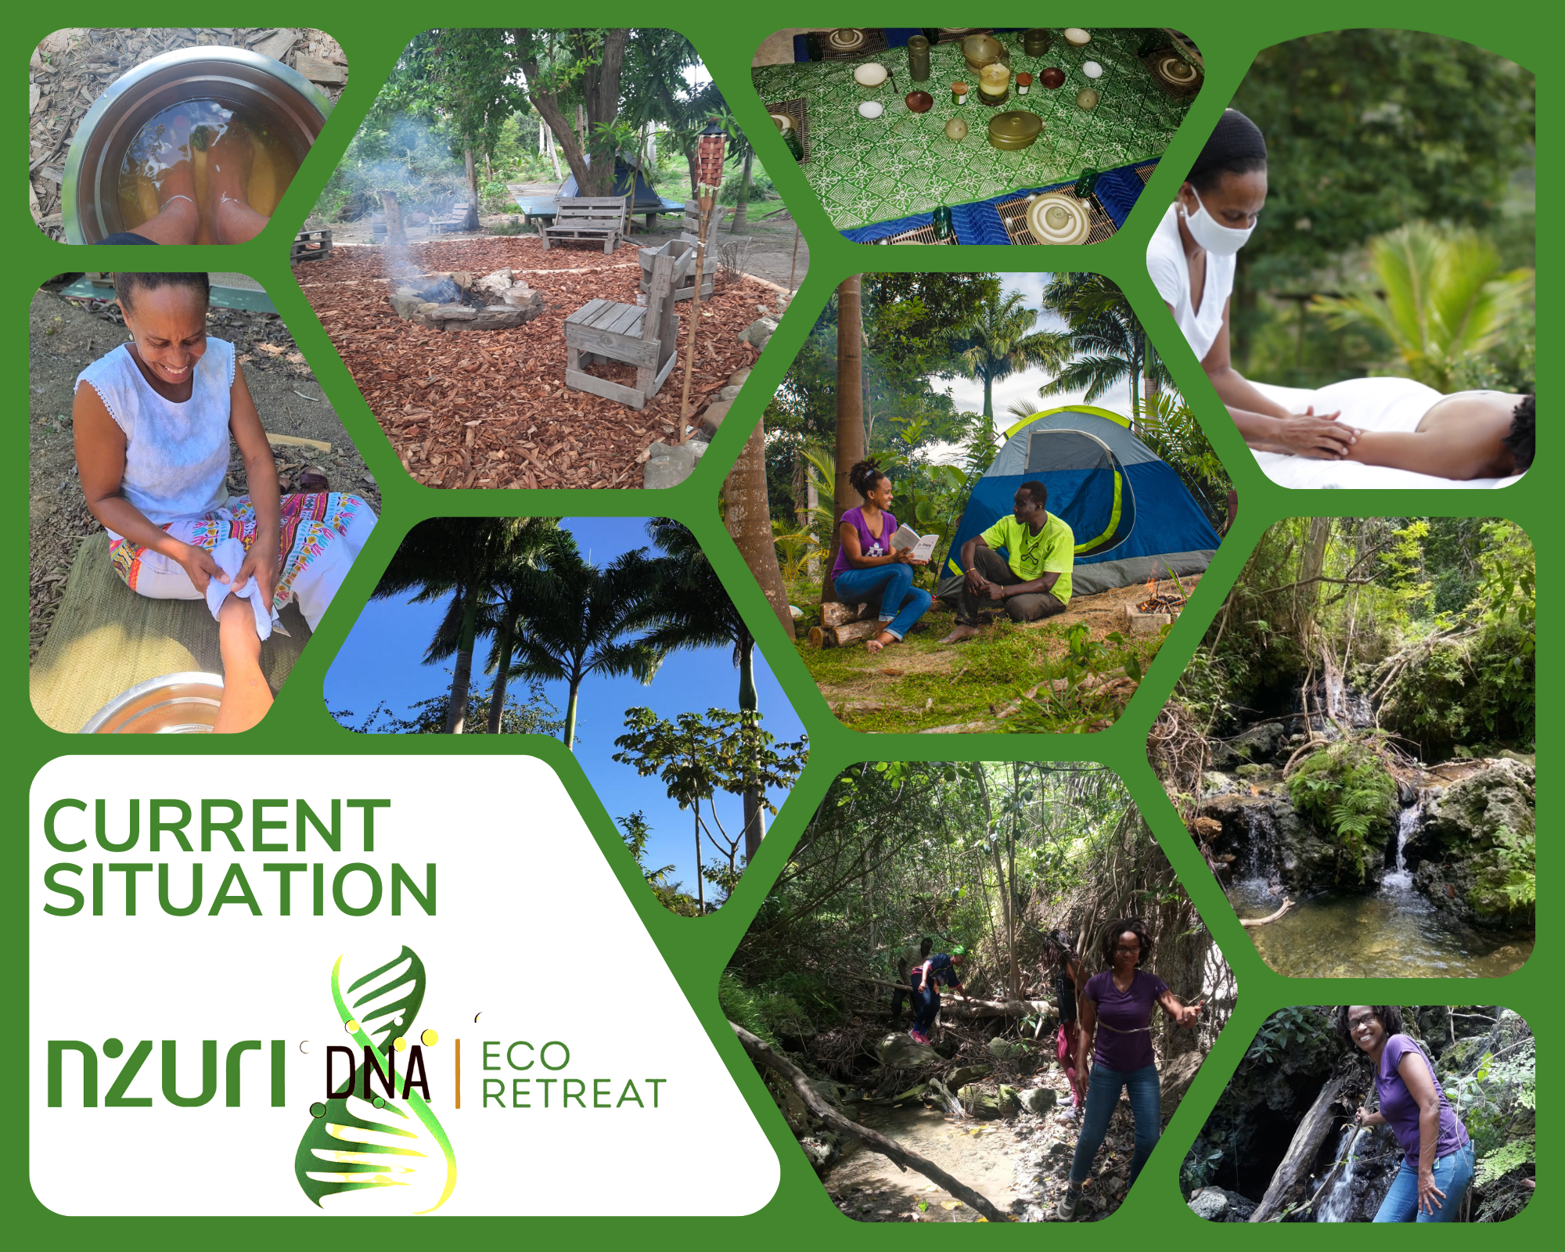

Our intention is to build out the space with cottages and other structures using bamboo, wood and other natural materials to provide an upscale experience in the forest, with sound ecological practices that do not disturb the natural environment.

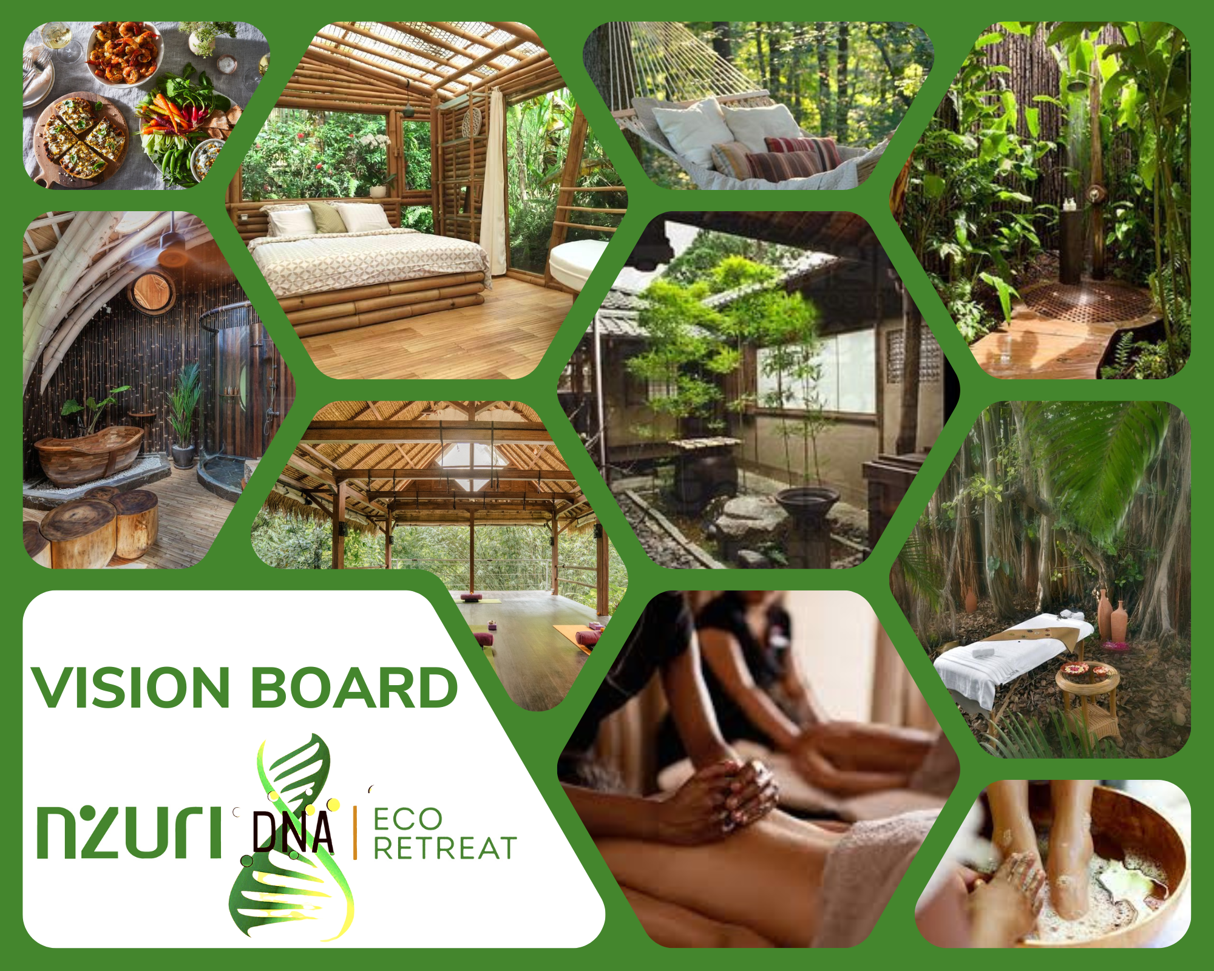

PROTECTING OUR ENVIRONMENT
With the use of permaculture techniques on the property, ready access to fresh spring water, solar energy and other natural resources, this space offers guests the opportunity to contribute to the preservation and stewardship of their environment. Our sustainable water and waste management systems help to protect the two waterways that border the properties from harmful pollutants. Guests can participate in some of our organic farming activities, including planting, composting, mulching and harvesting organic produce.

We have designed a smart farming, climate change resilient system to mitigate environmental risks identified and promote greater care and conservation of the eco system. The use of natural pesticides and organic fertilisers has minimised harmful chemical runoff permeating the soil and negatively affecting the waterway that borders the west side of our property. This waterway flows into the river course on the northern border that eventually finds its way to the East Coast beaches and Atlantic Ocean.

We intend to use biodegradable/organic products and ware for guests and staff, such as calabash bowls to decrease the amount of permanent waste for the landfill. Clearly marked composting, waste disposal and recycling bins will be used ensure proper management and separation of waste. As part of our communications with guests, we will impress upon them the importance of their participation in keeping the environment clean and litter free.

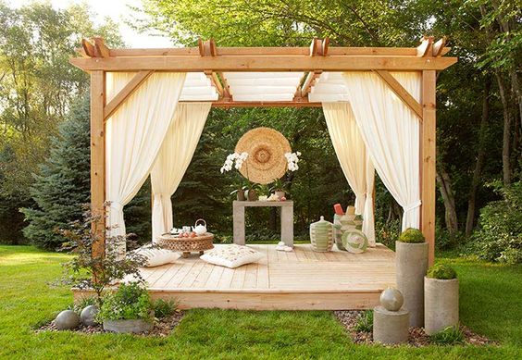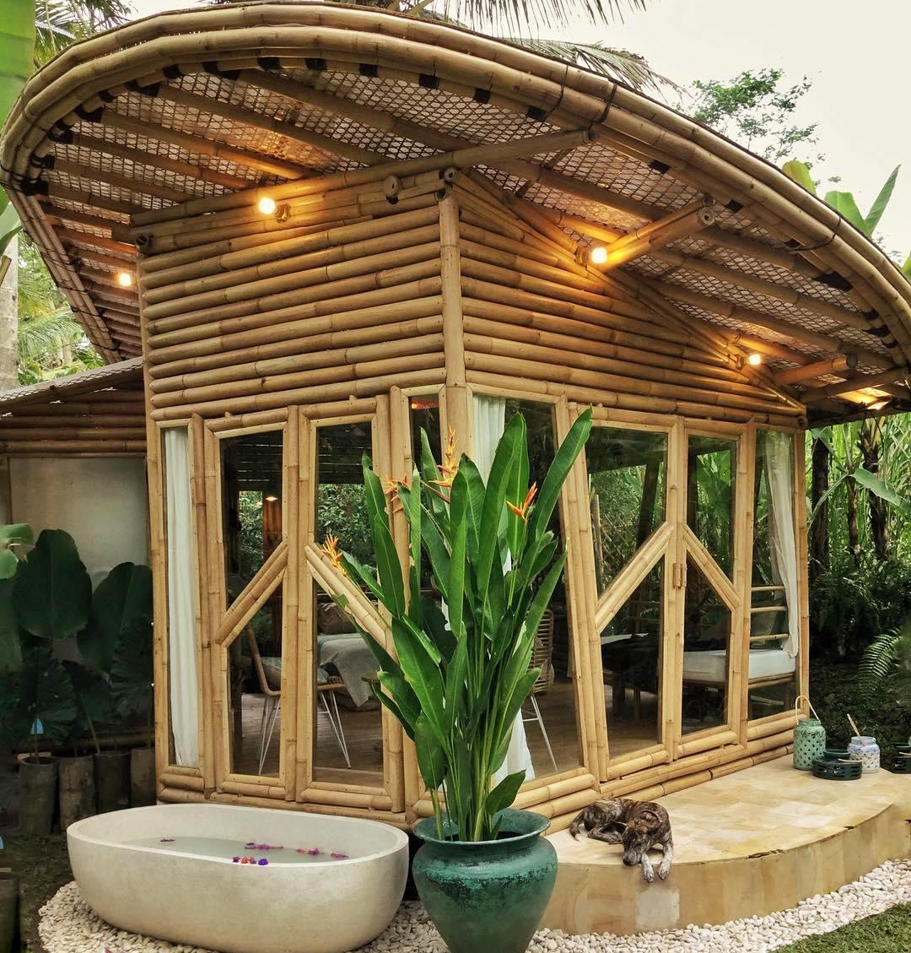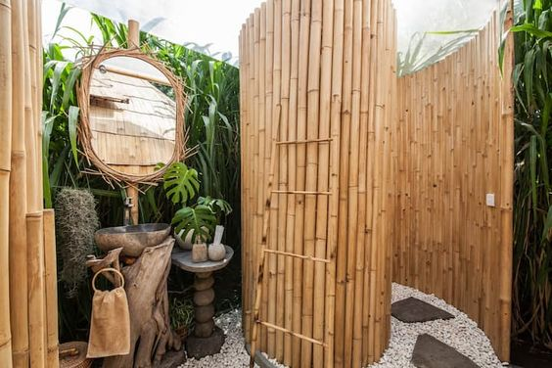

EDUCATING OUR GUESTS
We intend to create a platform of knowledge sharing, both virtually and in person, in which clients will gain access to many wellness discussions, including information on the wonderful world of healing herbs. These activities will take the form of hikes led by knowledgeable curators of the land. Guests will explore and forage the surrounding landscape, obtaining first-hand insight into our healing plants and herbs. These herbs will be dried and packaged for sale and used in our delectable menu items. Considering the ongoing pandemic and every changing protocol, we aim to facilitate online health and wellness workshops and podcasts that will feature interactive wellness conversations.

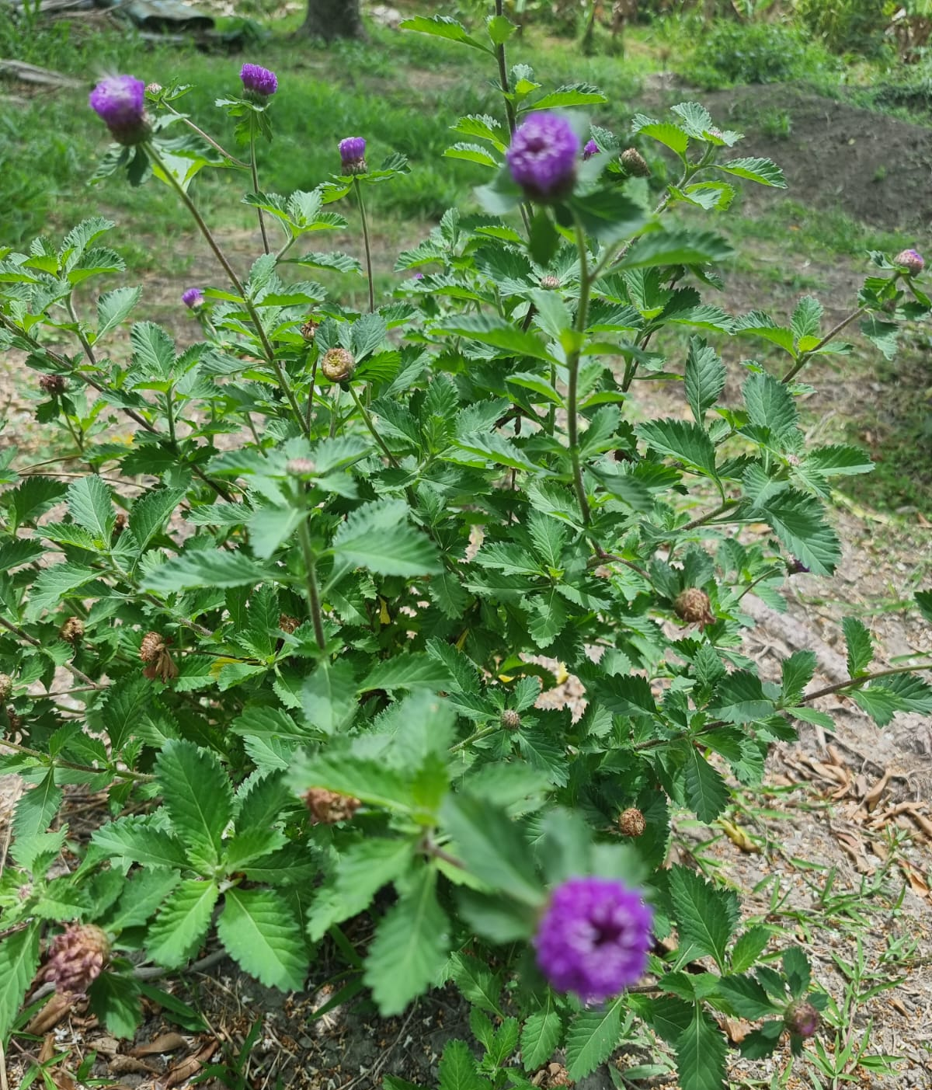

A.3. Management Team
Our management team is comprised of a diverse group of talented individuals from various complementary backgrounds. Over the course of the next few years, we are committed to building a resilient, sustainable organisation, generously giving of our time and expertise. We have experience in health and wellness, culinary arts, education, finance, marketing, entrepreneurship, sustainable agriculture, agro-processing and working with youth. We also receive support from and partner with several others who have significant experience in their respective fields and willing assist when called upon.

BIOS: THE CORE TEAM MEMBERS
Leah Clarke – Founder, Nzuri Eco Retreat
Leah worked for over 20 years in a corporate career in Finance and Risk Management in Barbados and New York City. She has experience in the hospitality sector and managed the credit portfolio of a Caribbean development finance institution that included 40% tourism based projects. While she has an MBA in Finance, she is currently a certified massage therapist and is passionate about holistic wellness. She is a holistic wellness coach and a business consultant who assists entrepreneurs in building successful businesses through strategic and tactical business planning. Leah plays a key role in the running of The Sojourner Foundation, assisting with administration, proposal writing, project management and the oversight and development of the Youth Farming and Leadership Programme. She also helps to teach the youth in the programme.

Akilah Love (Thomas) & Douglas Johnson - Co-founders, The DNA Brand of Companies
Akilah and Douglas bring a combined 30 years in philanthropy, fitness and wellness and community work in Canada, USA, Ghana, Barbados and Jamaica. Both have experience in sports, hospitality and entertainment and have produced numerous events. An ordained Minister, Akilah is a serial entrepreneur with a strong business sense. Douglas is a former elite basketball player and coach, certified personal trainer and sports consultant who has earned a stellar reputation producing and promoting signature shows and concerts in Canada and Atlanta.
A.4. Operations
PHASED OPERATIONS
Phase 1: June to December 2022
Themed camping spaces are being developed – 10 in the initial phase. Each space will be bordered by fruit trees, vines and plants and will include a hearth and grill for cooking/making tea and herbs that can be collected to make teas and various remedies. Phase 1 will also include the construction of 2 to 3 outdoor showers and compost toilets. Bamboo located on the property will be one of the key sources of building material. The space where the spa will be located will be cleared during this time, taking out the trees that are not needed and planting fruit trees and palms around the border. An interim covered space is being used for massage therapy (for individuals and couples) and other wellness services until the spa is constructed.

Phase 2: October 2022 to March 2023
The Nzuri-DNA spa and wellness studio will be built in the last quarter of the year once clearing has been completed and the materials acquired. It will be a multi-functional space in which different movement activities will be practised, including yoga, Pilates, dance, aerobics and martial arts along with several self care activities. A kitchen and agro-processing space will also be built in collaboration with The Sojourner Foundation for the production of value added items. Fresh produce and natural products will supply the guests of the eco retreat.

Phase 3: July 2022 to December 2023
An architect has been engaged to produce a master plan and design 7 to 10 cottages that will be used in addition to the camping spaces for the retreats (from overnight and weekend stays to 10-day retreats) and to facilitate higher end vacation accommodation for local, regional and international guests. Similar to the camping spaces, each cottage will be enclosed by lush, natural vegetation and will feature kitchen gardens and shared amenities.

ACTIVITIES/EVENTS
Various types of activities will take place in the eco retreat space including:
- Wellness retreats – may include various healing modalities and wellness services and activities such as:
  - Massage therapy (individual and couples)
  - Yoga/Pilates (individual and group)
  - Dance therapy
  - Martial arts events and training
  - Meditation
  - Journalling
  - On site spring hikes
  - Various local tours such as horseback riding, natural spring/beach excursions
- New moon and full moon activities
- Other self care activities
A.5. Social Impact
Nzuri-DNA Eco Retreat will have several social impacts:
- Improved health and wellness
- Mitigating some of the negative impacts of climate change and improving environmental resilience and sustainability
- Increasing sustainability for The Sojourner Foundation through financial and other contributions
- Providing greater opportunities for youth development and entrepreneurship in connection with The Sojourner Foundation’s Youth Farming and Leadership Programme
- Providing greater opportunities for partners to sell their products and services.
- Financial, Environmental and Social Sustainability Strategies
We will ensure the financial, environmental and social sustainability of the enterprise by:
- Providing exceptional products and services that generate repeat business and referrals
- Continuous improvement through customer feedback mechanisms
- Excellent property maintenance
- Superior management that is adaptable to changing circumstances
- Consistent innovation and new products/services
- Maintaining climate smart agricultural best practices to ensure a constant supply of food
- Robust monitoring and evaluation framework
- Involvement of youth

APPENDIX
Ap.1. Social Enterprise Name | Nzuri-DNA Eco Retreat | Ap.2. Location |  | Turner’s Hall, St. Andrew
Ap.3. Executing Organisation | Nzuri Eco Retreat in partnership with the DNA Brand Group of Companies
Ap.4. Retreat Objectives | Primary Objectives:  - Providing an environment to destress guests and facilitate healing  - An eco conscious model of doing business  - Demonstrating a healthier way of living  - Empowering youth  - Economic development
Ap.5. Value Proposition | - A TRUE ESCAPE  - Customised wellness experiences  - Beautiful, rustic natural environment  - Wellness education  - Organic produce and natural products (Farm to Table)  - Contributing to social causes  - Supporting Black initiatives |  | Retreat Packages May Include  - Hiking/Walking trails  - Camping  - Movement (e.g. yoga, dance)  - Massage therapy  - Meditation  - Energy healing  - Sound therapy  - Healthy, tasty meals
Ap.6. Main Customer Segments | - Frontline workers  - Business professionals  - Nature lovers
Ap.7. Key Partners/ Beneficiaries | - Nzuri Holistic Wellness  - DNA Group of Companies  - The Sojourner Foundation (TSF)  - J&P Farms |  | - Ocean Echo Stables  - Ocean View Yoga Retreat  - Students  - Volunteers
Ap.8. Key Resource Needs | - Infrastructure  - Equipment and Materials  - Wellness Professionals  - Other Partners
Ap.9. Implementation Approach | A number of organisations and individuals are collaborating to design, develop and operate Nzuri-DNA Eco Retreat. We will utilise TSF’s leased multi-acre property, with its available natural resources, to provide various health and wellness services, including wellness and self care retreats, fresh, organic produce and natural products to our various target markets. Human resources will include youth from TSF’s youth programmes and other community members who share the same eco conscious values.

